Price List for Bryan Zanisnik: Centimeter
All works $500 framed, $400 unframed

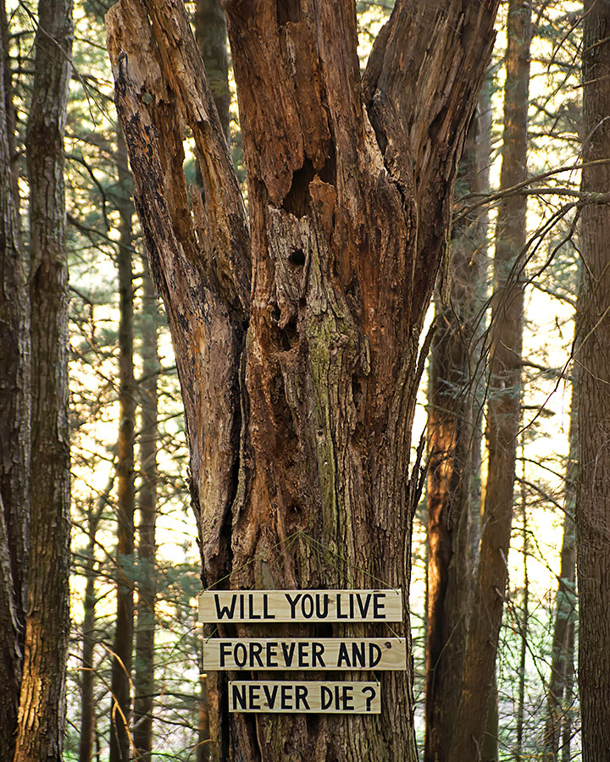
Live Forever
Digital Photograph
20 x 16 inches
2022, Edition of 5

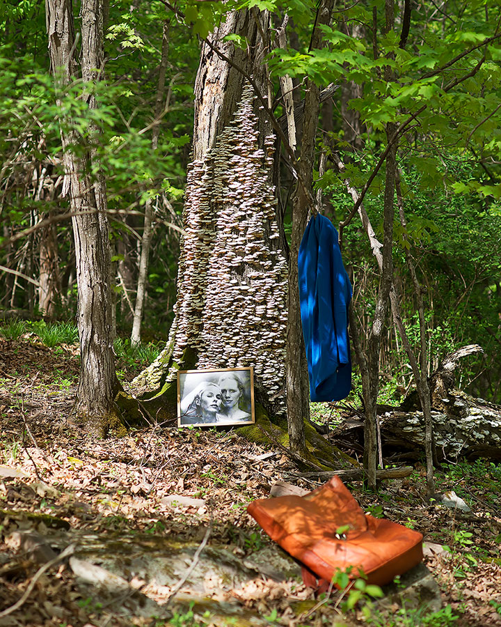
Bergman’s Persona
Digital Photograph
20 x 16 inches
2022, Edition of 5
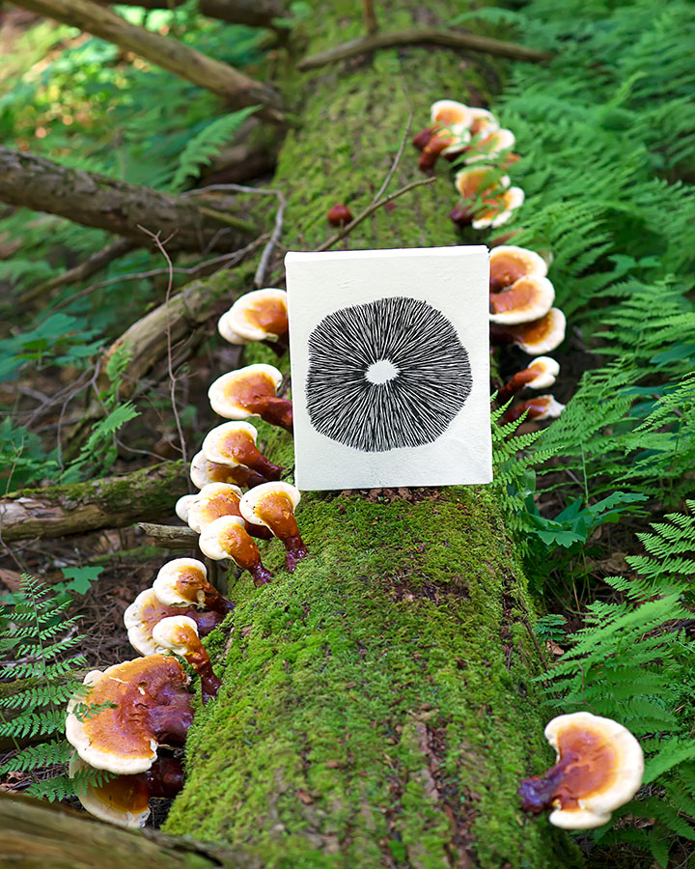
Ganoderma
Digital Photograph
20 x 16 inches
2022, Edition of 5

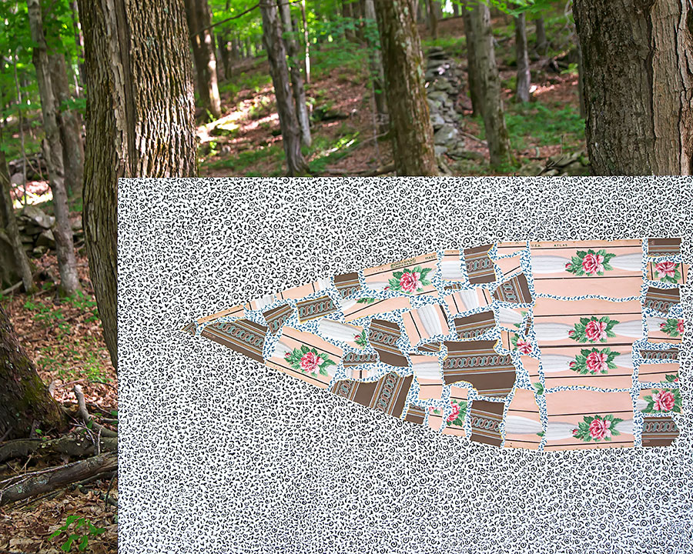
Rose Arrow
Digital Photograph
16 x 20 inches
2022, Edition of 5

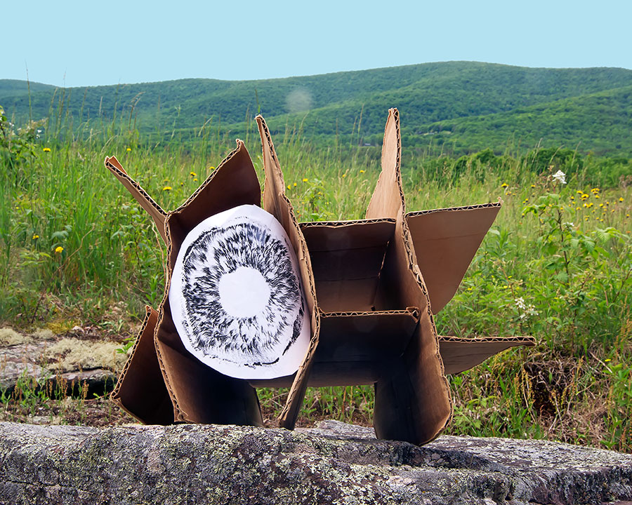
Spores
Digital Photograph
16 x 20 inches
2022, Edition of 5

Many Faced God
Digital Photograph
16 x 20 inches
2022, Edition of 5
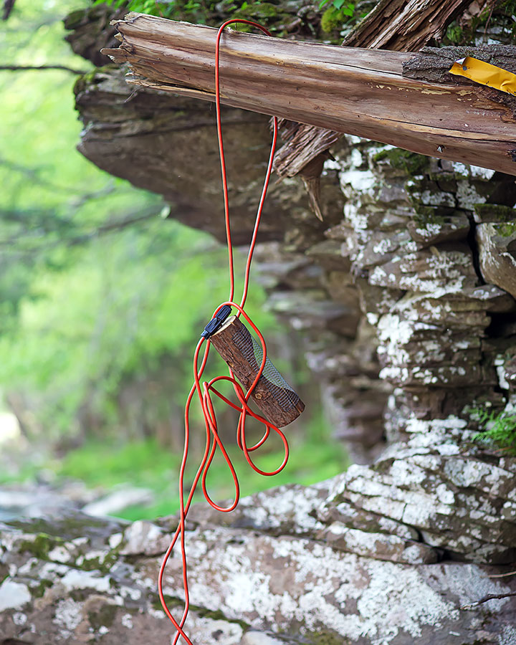
Rock Climber I
Digital Photograph
20 x 16 inches
2022, Edition of 5

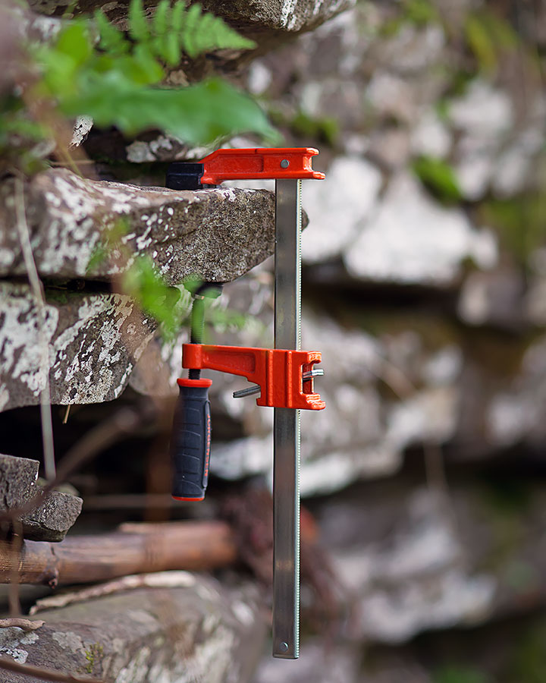
Rock Climber II
Digital Photograph
20 x 16 inches
2022, Edition of 5

